**Procedures PRD**

**Philosophy**

The basic philosophy of the procedure capability appears in section 9 of the PRD. In brief, an authorized user may create one or more procedures, which can be linked to notifications via the appropriate Settings dialog. When a particular type of notification is issued, a procedure is linked to it and is available for recipients to view.

Procedures are user-selected and user-written by an authorized user. The authorized user decides what a procedure contains, and what types of notifications it is associated with.

Previous documentation (cf PRD 5.1.1) indicated that procedures may be associated with SkyGuard warnings, public warnings, alerts, queries, local storm reports, status messages, and system messages. On 9/12/14, Casey added to this list forecasts for monitored locations, including mesoscale model forecasts and storm potential notices.

**Granularity**

An increasing number of criteria for associating a procedure with any of the above types of notifications have been proposed. These criteria envision a multidimensional binding, where each combination may have a unique procedure associated with it.

* Type of notification. A SkyGuard tornado warning is likely to require a different action than a system message or a local storm report. As listed above, there appear to currently be ten known possibilities for type of notification.
* Monitored location, place or region affected. The procedure for a snow warning is likely to be different in Buffalo than in Atlanta. The examples that have been proposed indicate that all geographic specifiers in the portal can be used to bind procedures, including monitored location (SkyGuard warning), place (alert), and region (SPN) (and perhaps also custom region?). Examples have also been proposed in the 9/12/14 flowchart that indicate the procedures would vary even within the monitored location category (for example, to designate the safest location in a tornado in each individual store.)
* Type of event warned for. This is, for example, the contrast between snow, tornado, air quality, etc. in SkyGuard or public warnings, or reported snow vs reported trees down in local storm reports. It has been proposed that this is a two-level classification, in which the notifications are first classified as “short fuse” or longer term threats, and then further classified in terms of type of weather event. The specific number of event types will be large, given the inclusion of public warnings, as the NWS issues over 80 types of warnings, watches and advisories.
* Role. It is envisioned that users may choose to differentiate not only horizontally (security vs marketing vs merchandising) but also vertically (assigning different procedures to store manager and assistant store manager in a tornado.)
* Stage. It has been proposed that the procedure functionality needs to distinguish between the pre-event notification and the all-clear. Since there is also considerable customer interest in receiving updates after the initial notification, this probably also requires another level of procedure.

From the above listing, known parameters, and Casey’s suggestions as to how the procedure capability would be implemented at Lowe’s, the order of magnitude of the decisions a client may make – and the amount of procedures we have to store and process – could be quite large. For example, it appears, based on the 9/12/14 flowchart, that Lowe’s would potentially make decisions on this many procedures to bind to notifications:

Type of notification 10 x

Geographic specifiers up to ~1800 x

Type of event warned for up to ~100 x

Role at least 5 x

Stage 3 =

Potential Lowe’s procedures 27,000,000

Is this an indication that we are making this too complex?

**Create/Edit/Delete Procedure**

The basic interface – which is similar to something already developed by Nick – could look like this wireframe.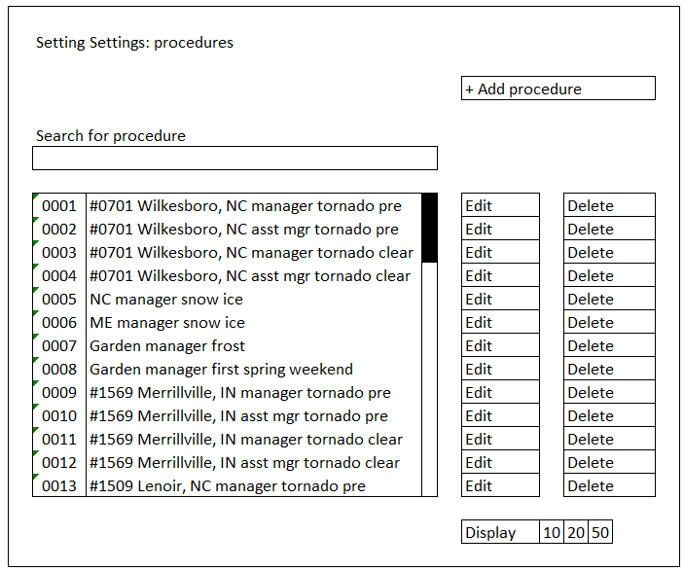

Note the items filled in as examples, which illustrate the granularity envisioned in the current discussions. The response to snow and ice might be uniform for large areas, implemented by the portal concept of the location set. Some things – like frost affecting the garden center – might be handled by very uniform procedures, while the response to an imminent danger such as a tornado may vary by store (designating the safest place in each store). There may be multiple roles associated with each notification (one manager in the safe place, one at the front door.) And separate procedures might be provided for first warning and all clear on a tornado.

This implies that the interface needs to scroll, needs a search function, and needs to designate how much data to display at one time.

Because of the volume of choices required, it is recommended that the create/edit interface operate through a series of accordions, analogous to the side bar. These are shown in the wireframe as down arrows.

In addition, Casey has proposed that the procedures be one of two forms – a 200-character format for imminent danger and a long-form format for other situations. Thus, whereas clicking Edit takes the authorized user to a form that is filled out with the current information about the selected procedure, clicking Add Procedure takes the authorized user to a truncated this dialog that is a blank form forcing an immediate choice via a radio button:

Depending on the choice, the dialog then expands into one of two versions.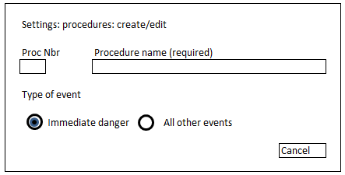

In the creation of either format of procedures, both a name and a number are required – the name for easy recognition in the various dialogs and the number to save space in monitor modules. The process number should be autogenerated as the next unused number, each time the user visits this dialog.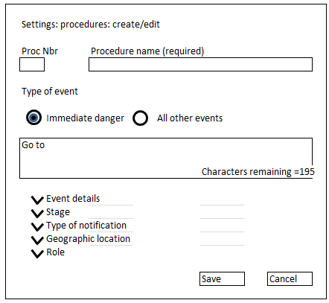

If the “immediate danger” setting is chosen, the dialog to enter the procedure (shown in wireframe at left) limits the length to 200 text characters. This limit is enforced by a counter. Video or graphics may not be associated with the procedure.

If “all other events” is chosen, a different dialog appears (shown on next page.) Engineering has requested that the procedure in Phase 1 be limited to “rich text.” Note that many standard on-line technical dictionaries define “rich text” as text that includes formatting commands for page layout such as fonts, bold, underline, italic, etc., and often also page formatting options, such as custom page margins, line spacing, and tab widths. We need to be clear on which, if any, of these highly desirable features we are supporting. If we support few or none, the documentation should avoid the use of the term “rich text” to describe the procedure content. It was also previously agreed that, in Phase 1, the procedure may also include user-specified links to graphics and video.

This matter was raised over two weeks ago, but no comments have been received. Therefore the rich text formatting tools continue to appear in this wireframe.

The document “Sidebar item 6 9 14.xlsx” reiterated the previously stated requirement (in “3Twenty9 Requirements Gathering” of 1/20/2014) that procedure content could be uploaded by the user. Again, Engineering appears to be arguing instead for a “fill in the box” (perhaps with cut-and-paste) way of entering procedures in Phase 1.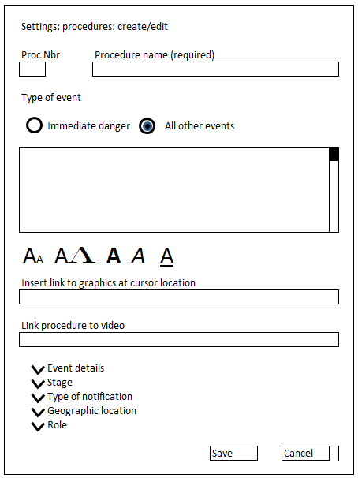

The procedure text box needs a vertical scroll bar when a large amount of text is inserted.

We need to make a decision as to whether we truly mean rich “rich text” or just “text”. If the former, will the dialog box preserve formatting in the material that is cut and pasted into the box? If not, some sort of text formatting function bar will be needed. (Cf. the bar that appears at the top of the docs.google window, or the bottom of the gmail window.) This is shown beneath the text cut-and-paste box in the wireframe.

In either event, it would be desirable for the procedure text box to be WYSIWYG

It seems unlikely that there will need to be more than one linked video. However, there might be a number of graphics in a procedure, and they will be most meaningful if positioned near the text they illustrate. The proposed interface in the wireframe allows the user to insert the link to them at the cursor position (akin to the Insert Hyperlink function in WORD.)

**Accordions**

All accordions must be completed for each of the two formats of procedure. (This is another suggestion that we may be making this too complex.) The Save button will give an error message if this is not done.

**Event details accordion.** This accordion presents a drop-down of all types of events – each type of SkyGuard warning, each type of public warning, watch or advisory, each category of local storm report, etc. This will be a large taxonomy, but it can be reused for the sorting function on the various notification index pages. The default is ALL. Optimally, the drop-down presents only the products the client is subscribed for (that is, if they did not buy the SkyGuard ice warnings, those do not appear in the list, etc.)

**Stage accordion.** Two stages are already identified: the initial, pre-event notification and the all-clear. To get the greatest customer value from this feature, we should implement a frequent request in the September 2013 interviews: a reconfirming update during the warning period, even if there has been no change. This would obviously require some change in the forecasting process. These two – or three -- choices could be offered via a radio button. The default is initial notification.

**Type of notification accordion.** This choice is made via a drop-down menu, with the choices SkyGuard warnings, public warnings, alerts, queries, local storm reports, forecasts for monitored locations, mesoscale model forecasts, storm potential notices, status messages, and system messages. Optimally, the drop-down presents only the products the client is subscribed for (that is, if they did not buy the optional local storm reports, those do not appear in the list, etc.) The default is ALL.

**Geographic location accordion.** This will need to offer five drop-downs, presenting the individual monitored locations, location sets, favorite places, favorite regions, and custom regions. A selection from any of the five drop-downs satisfies the dialog. There is no default.

**Role accordion.** This dialog presents a drop down showing the roles currently defined in Settings: Users and contacts: Manage roles. There is no default.

**Casey’s diagram of 9/12/14**